**TRƯỜNG ĐẠI HỌC KHOA HỌC TỰ NHIÊN TPHCM**

**KHOA CÔNG NGHỆ THÔNG TIN**



**NHÓM 14**

# **Hệ thống thông tin phục vụ trí tuệ kinh doanh**

**BTVN#3**

20127122 - Phạm Thái Bình

20127223 - Nguyễn Bùi Hoàng Lam

20127561 - Nguyễn Hoài Mẫn

20127649 - Nguyễn Trí Trạch

GVHD: Hồ Thị Hoàng Vy

**Bài 1: Dựa vào source system được cung cấp, hãy thiết kế NDS + DDS cho nhu cầu phân tích**

**NDS**

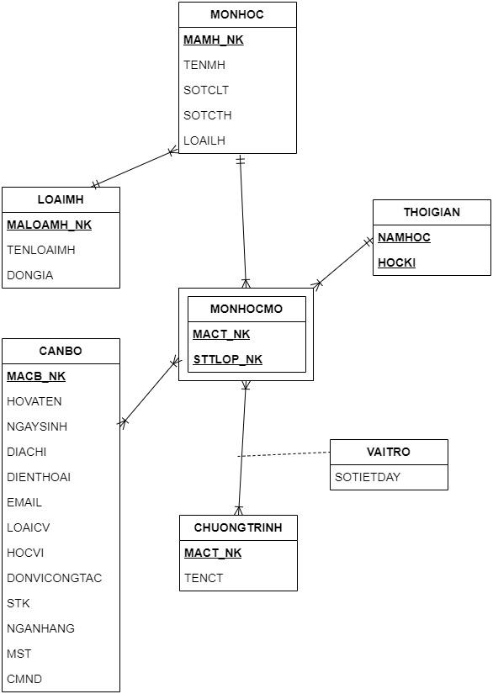

**DDS**

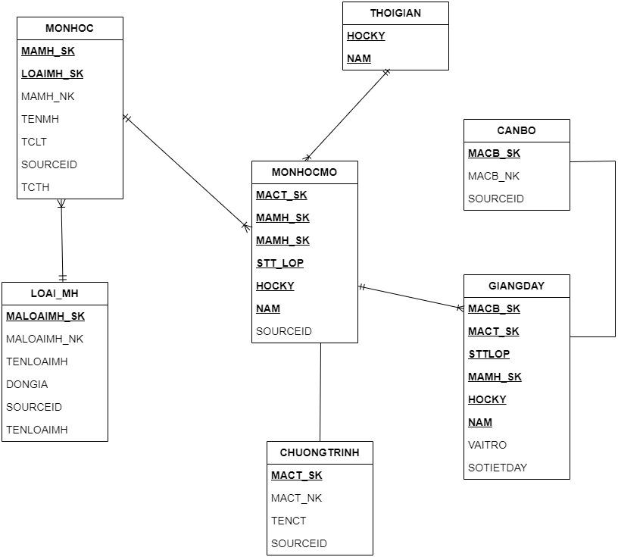

**Bài 2: Xác định các phép biến đổi để ETL dữ liệu từ source-> DW**

**\* ETL SOURCE -> NDS**

- SELECT CB.MACB, CB.HOVATEN, CB.NGAYSINH, CB.DIACHI, CB.DIENTHOAI, CB.EMAIL, CB.LOAICB, CB.HOCVI, CB.DONVICONGTAC, CB.STK, CB.NGANHANG, CB.MST, CB.CMND

FROM SOURCE.CANBO CB

INSERT INTO NDS.CANBO(MACB,HOVATEN,NGAYSINH,DIACHI,DIENTHOAI,EMAIL,LOAICB,HOCVI,DONVICONGTAC,STK,NGANHANG,MST,CMND)

- SELECT NAMHOC,HOCKY FROM SOURCE.THOIGIAN

INSERT INTO NDS.THOIGIAN(NAMHOC,HOCKY)

- SELECT MACT, TENCT FROM SOURCE.CHUONGTRINH

INSERT INTO NDS.CHUONGTRINH(MACT, TENCT)

- SELECT MAMH_NK, TENMH, SOTCTL, SOTCTH, LOAIMH FROM SOURCE.MONHOC

INSERT INTO NDS.MONHOC(MAMH_NK, TENMH, SOTCTL, SOTCTH, LOAIMH)

- SELECT MALOAIMH_NK,TENLOAIMH,DONGIA FROM SOURCE.LOAIMH

INSERT INTO NDS.LOAIMH(MALOAIMH_NK,TENLOAIMH,DONGIA)

- SELECT MACT_NK, STTLOP_NK FROM SOURCE.MONHOCMO

INSERT INTO NDS.MONHOCMO(MACT_NK, STTLOP_NK)

- SELECT SOTIETDAY FROM SOURCE.VAITRO

INSERT INTO NDS.VAITRO(SOTIETDAY)

**\*ETL NDS -> DDS**

INSERT INTO DDS.MONHOC (MAMH,LOAIMH,TENMH,SOTCLT,SOTCTH,TENLOAIMH,DONGIA)

SELECT MH.MAMH,MH.LOAIMH,MH.TMH,MH.SOTCLT,MH.SOTCTH,MH.TENLOAIMH,MH.DONGIA

FROM NDS.MONHOC MH JOIN NDS.LOAIMONHOC LMH ON MH.LOAIMH=LMH.MALOAIMH

-INSERT INTO DDS. DIM_THOIGIAN(NAMHOC,HOCKY)

SELECT NAMHOC,HOCKY FROM NDS.THOIGIAN

- INSERT INTO DDS.MONHOC (MAMH,TENMONHOC,SOTCLT,SOTCTH,DONGIA,MALOAI)

SELECT MH.MAMH,MH.TENMONHOC,MH.SOTCLT,MH.SOTCTH,LMH.DONGIA,LMH.MALOAI

FROM NDS.MONHOC MH JOIN NDS.LOAIMONHOC LMH ON MH.MALOAI=LMH.MALOAI

-INSERT INTO DDS.CHUONGTRINH(MACT,TENCT)

SELECT MACT,TENCT FROM NDS.CHUONGTRINH

INSERT INTO DDS.GIANGDAY (MACT,MAMH,STTLOP,HOCKY,KEYNAMMH)

SELECT CT.MACT,MH.MAMH,DMH.KEYMH,GD.SOTIETDAY,TG.HOCKY,TG.NAMHOC

FROM NDS.CHUONGTRINH CT JOIN THOIGIAN JOIN GIANGVIEN GV ON

GD.MAGV=GV,MAGV

INSERT INTO DDS.GIANGDAY (MACB,MACT,STTLOP,MAMH,HOCKY,NAM,VAITRO,SOTIETDAY)

SELECT CB.MACB,MHM.MACT,MHM.STTLOP,MHM.MAMH,MHM.HOCKY,MHM.NAM,VAITRO,SOTIETDAY

FROM NDS.GIANGDAY GD JOIN CANBO CB ON GD.MACB=CB.MACB

INSERT INTO DDS.CANBO (MACB)

SELECT CB.MACB, SOURCEID

FROM NDS.CANBO CB JOIN NDS.GIANGDAY GD ON GD.MACB=CB.MACB